1. Introduction

In this phase of our project our main goal is to define our software objects and model both visually and textually how they collaborate to fulfill the requirements that were mentioned during our analysis. In this phase we will construct a conceptual solution to our game’s requirements, so that this report will play a key role in the implementation phase of our project.

* 1. Purpose of the system

System is a text based game and designed for entertaintment. In the game player has a character and by using command prompt player commands his character to perform actions like moving around, killing enemies, collecting items, inspecting surroundings etc. Aim of this game is exploring the world while keeping his character alive.

* 1. Design Goals
* Allow user to complete their task without being distracted by software or losing train of thought
* After user types commands system responses in less than one second
* Allow user to run the system on all types of operation systems
* Give users access to information they need to complete their task (i.e. information on other pages, etc.).
* Add clear tutorial about game to the help menu to make system easily understandable
* System will not interrupt the game play because of the small typos of the player
* System can be modified without changing entire structure of it

2. Software Architecture

We design our system in Model- View- Controller Architectural Style. It is the best convenient way for us.

2.1 Subsystem Decomposition

We decided to handle our games in 5 subsystems which connect themselves with the interactions shown in the figure. Details about subsystems and their classes are given in the subsystem services part.

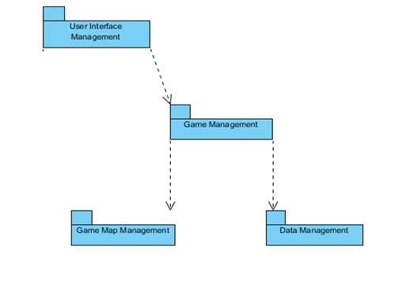

2.2 Hardware / Software Mapping

In our project Java will be used as a programming language. Users who has enough tool to execute Java projects will be able to execute our program. Only software requirement for pur system is that.

When issue comes to hardware requirements, a regular keyboard is enough. Keyboard will be used to initialize the game, enter login information and commands to direct the game.

As a result, our project is not required an extra tool than that already exist in all computers.

2.3 Persistent Data Management

User information and save files will be saved as .DAT files to the harddrive. Interior of these files will be decided during implementation.

2.4 Access Control and Security

Upon creation of an account, login credentials of that account will be stored to the harddrive. When an user wants to play the game players must type in their login ID’s and passwords. If login is successfull their game data will be loaded and game will start. Otherwise they will get an error message explaining the situation. Users can access other players via a proxy and they only will be able to see their game condition and scores.

2.5 Boundary Conditions

Initializaton

Since Zoork does not have regular .exe or such extension, it will not require any installation. Game will be initialized via a .jar file.

Termination

Because of the neccessity of saving, game must be terminated with exit command otherwise system will not be able to save and store game data and will lose the process achieved since last save.

Error

In the case of the corruption of the data system will not be able to recover the data and all processes will be lost.